Fitchburg State University

CSC 7014 Practice Computer Programming

Instructor: Nguyen Thai

Due: 9/30/2016 at 5:00 PM

Student:

**CSC 7014 Assignment 3: Chinese Zodiac**

The purpose of this assignment is to learn how to program the if-elif-else statements and also enhance your graphics programming skills. Your program is to be written in the Python language. You are required to use Turtle graphics as user output presentation. You will be graded for output correctness, code comments, code indentation, descriptive variables and source code file header completeness.

As you work through the assignment be sure to answer all questions (type your answers into this document) and take all screenshots as requested (copy them into the document). For the screenshots, you can use the Snipping Tool that is built-in to Windows to capture the important parts of the lab as highlighted in the document below. Do not delete the contents of this file. When finished, you will submit the document source code file and associated data files to the instructor via Blackboard. DO NOT SUBMIT ZIP FILES OR INDIVIDUAL IMAGES. If you have any questions or need any clarification, email the instructor *before* the deadline.

1. In this lab you are to write a program in Python called *chineseZodiac.py* to calculate the Chinese Zodiac for a given user input as a year number.
2. You are to create a Chinese Zodiac with 12 animal names on a circle as shown below. You are required to use Turtle graphics to create the Chinese Zodiac circle. The radius of the circle is 200 units long. The zodiac circle is to be drawn with black color.

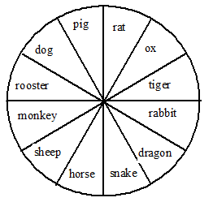

1. The Chinese Zodiac is based on a 12-year cycle, and each year in the cycle is represented by an animal in following order:
2. Monkey
3. Rooster
4. Dog
5. Pig
6. Rat
7. Ox
8. Tiger
9. Rabbit
10. Dragon
11. Snake
12. Horse
13. Sheep

The value of (year % 12) determines the zodiac sign. For example, 1900 is the year of the rat, since (1900 % 12) is 4.

1. Prompt the user to enter a year number as an integer. You need to check for valid input. For example, negative number is invalid.
2. Calculate the zodiac sign and label the animal name that corresponds to the user’s input in red on the zodiac circle. Label the other eleven animal names in blue.
3. Label your diagram with the title “Year to Chinese Zodiac Conversion”.
4. Write the user’s input and your calculated output on the diagram as:

Year 1900 is the rat!

1. Before coding, think how you are going to tackle this problem, and write a short description of the logic of your program.

I am going to proceed with the following steps.

1. Create a loop to check whether the given year is valid or not. If the given year is not valid then the loop repeats until it get a valid input. If the given year is valid then the program continues to next step.

2. The zodiac animal is calculated depending on the users input(year%12).

3. Draw the circle and use for loop to divide the circle in to segments and to name them.

4. The segment lables and the value calculated using users input(year) are compared,if both are same then the animal name is displayed in red color else in blue.

5.If and else condition, is used to label the animal name that corresponds to the user’s input in red on the zodiac circle and other are in blue.

1. **INSERT YOUR DESCRIPTION HERE.**

First turtle is imported.

1. “While” loop iterates and asks for user input. If the input is valid, code continues . If the user enters incorrect input, the while loop prompts for another input, this will continue till the user provides the valid input.Once the user provides the valid input, then the zodiac sign is calculated (i=year%12), based on the input number(line 21) .
2. (line 23 to 26)Now setting up the output screen, here dimensions(LxW) are used to set the screen size,using setup option from turtle(turtle.setup(600,600) ).Then screen is instantiated and screen color is declared(using bgcolor).
3. Now a pen is created and pen size is declared(line 30&31).
4. Instantiate circle of given radius(line 36).
5. Drawing a circle: here a circle is drawn using the forward, right ,left options from turtle. Rolling block is used to draw 12 segments in circle(line 51) and blocks array is used to declare the size of each block.
6. Initialising lables.Here the 12 animal names are taken in to an array called segment_lables. Both x and y axis are used to declare the co-ordinates for segment lables(line 57&58).
7. Each block of 30 degrees is taken and drawn using a pen of color black. For loop is used to draw for all the 12 segments(lines 60 to 72).
8. The segments are named with 12 animal names using a “for loop”. “If –else” condition is used to display the output(result) in “Red” and all the other animals names in blue
9. he zodiac circle is labelled at desired coordinates by using the ballpen.write key word from the turtle.(line 89 to92)
10. Output is displayed on the screen along with the year(input) entered by the user.
11. Finally Ballpen has hidden by using the command ballpen.hideturtle() and code is ended.
12. **TAKE A SCREENSHOT** of your input and output, and paste them here. Do not paste your source code in this document.

**Input:**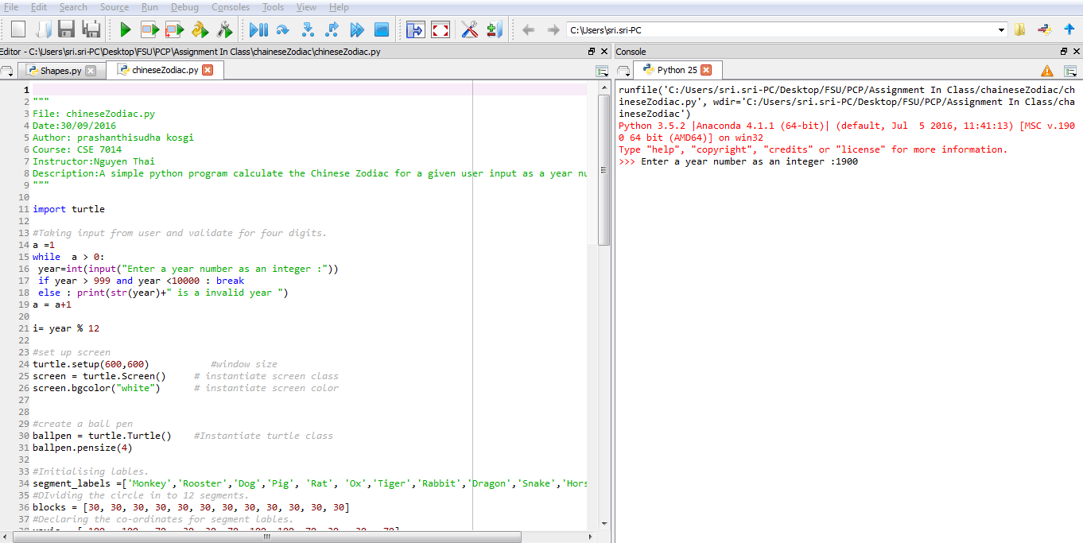

**Output:**

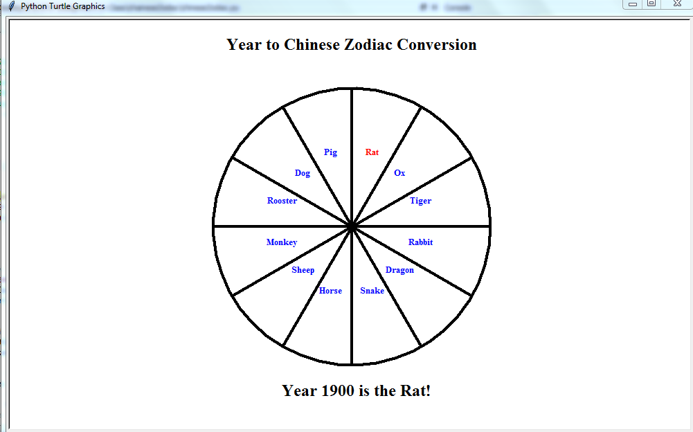

1. Submit your source code (chineseZodiac.py) and this document to Blackboard for grading.